Overview slides
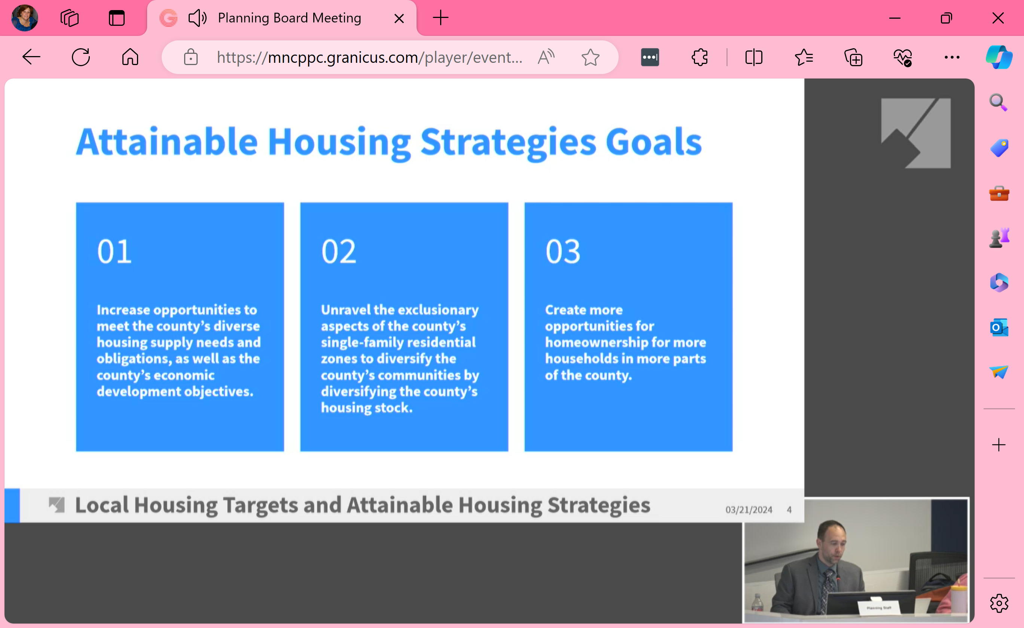
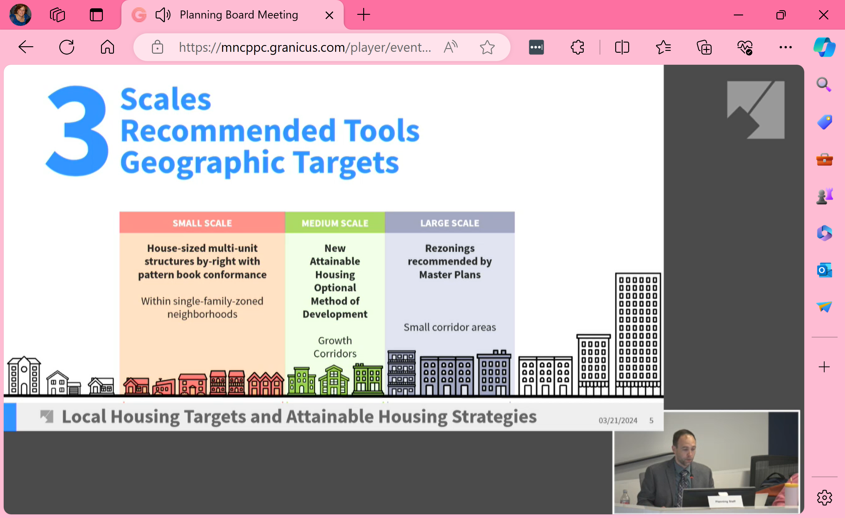
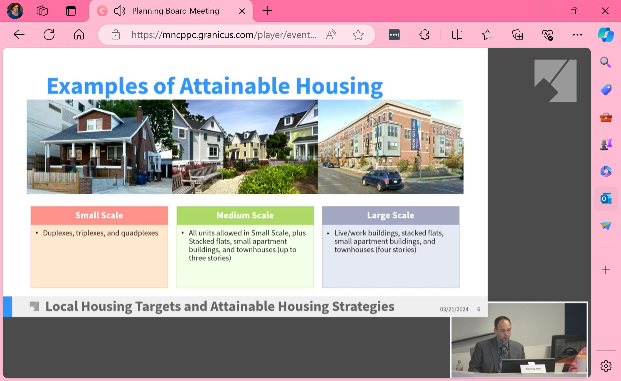
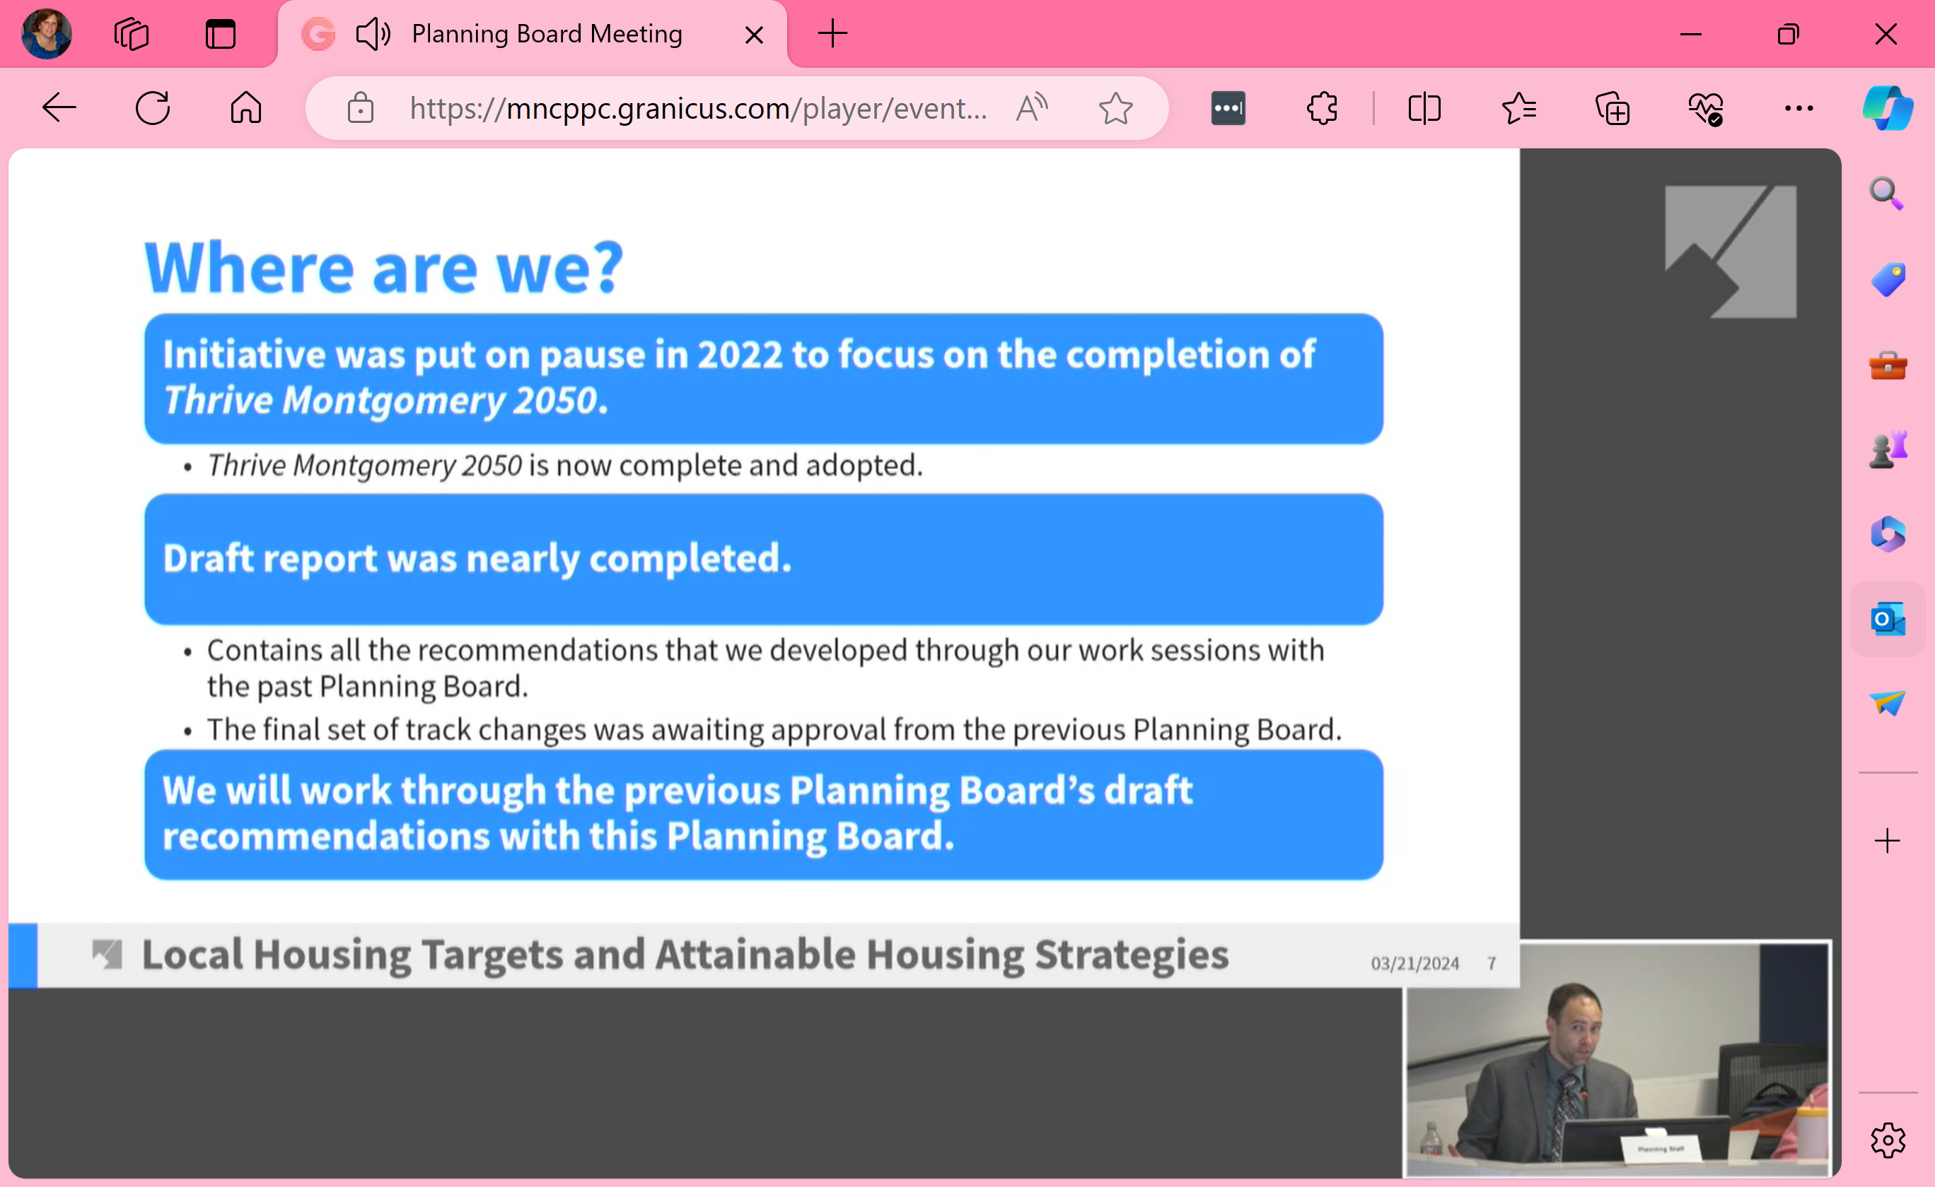
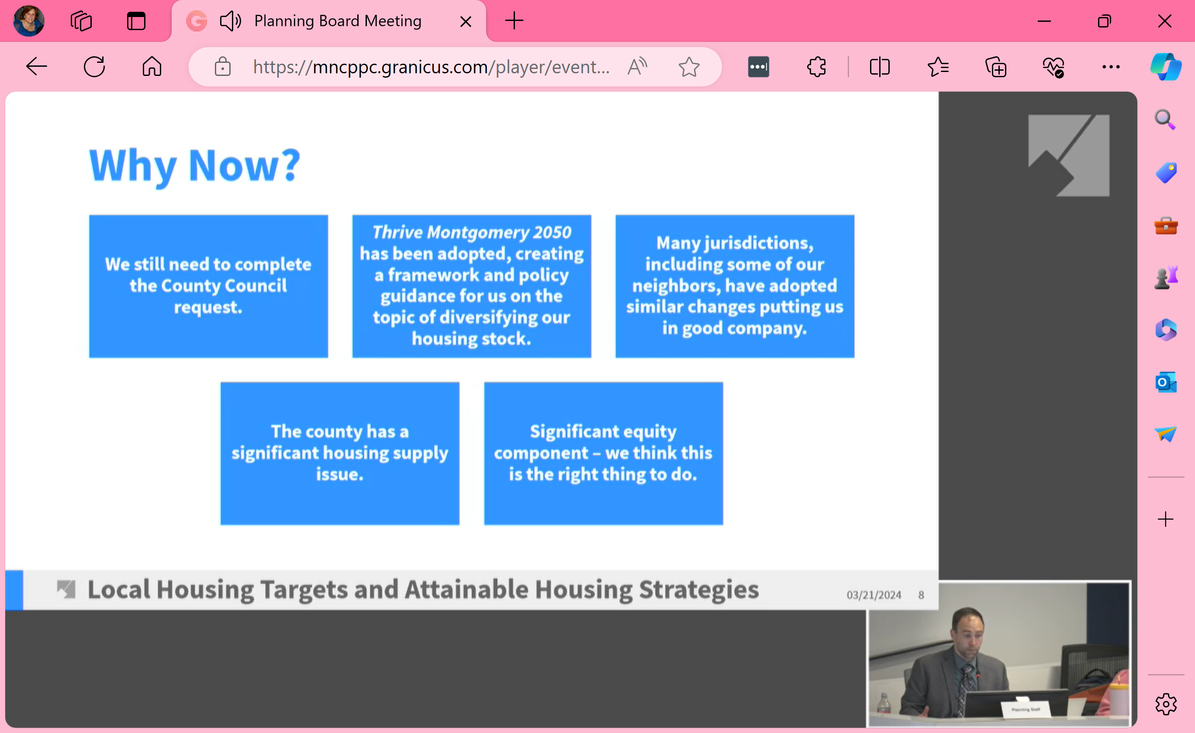
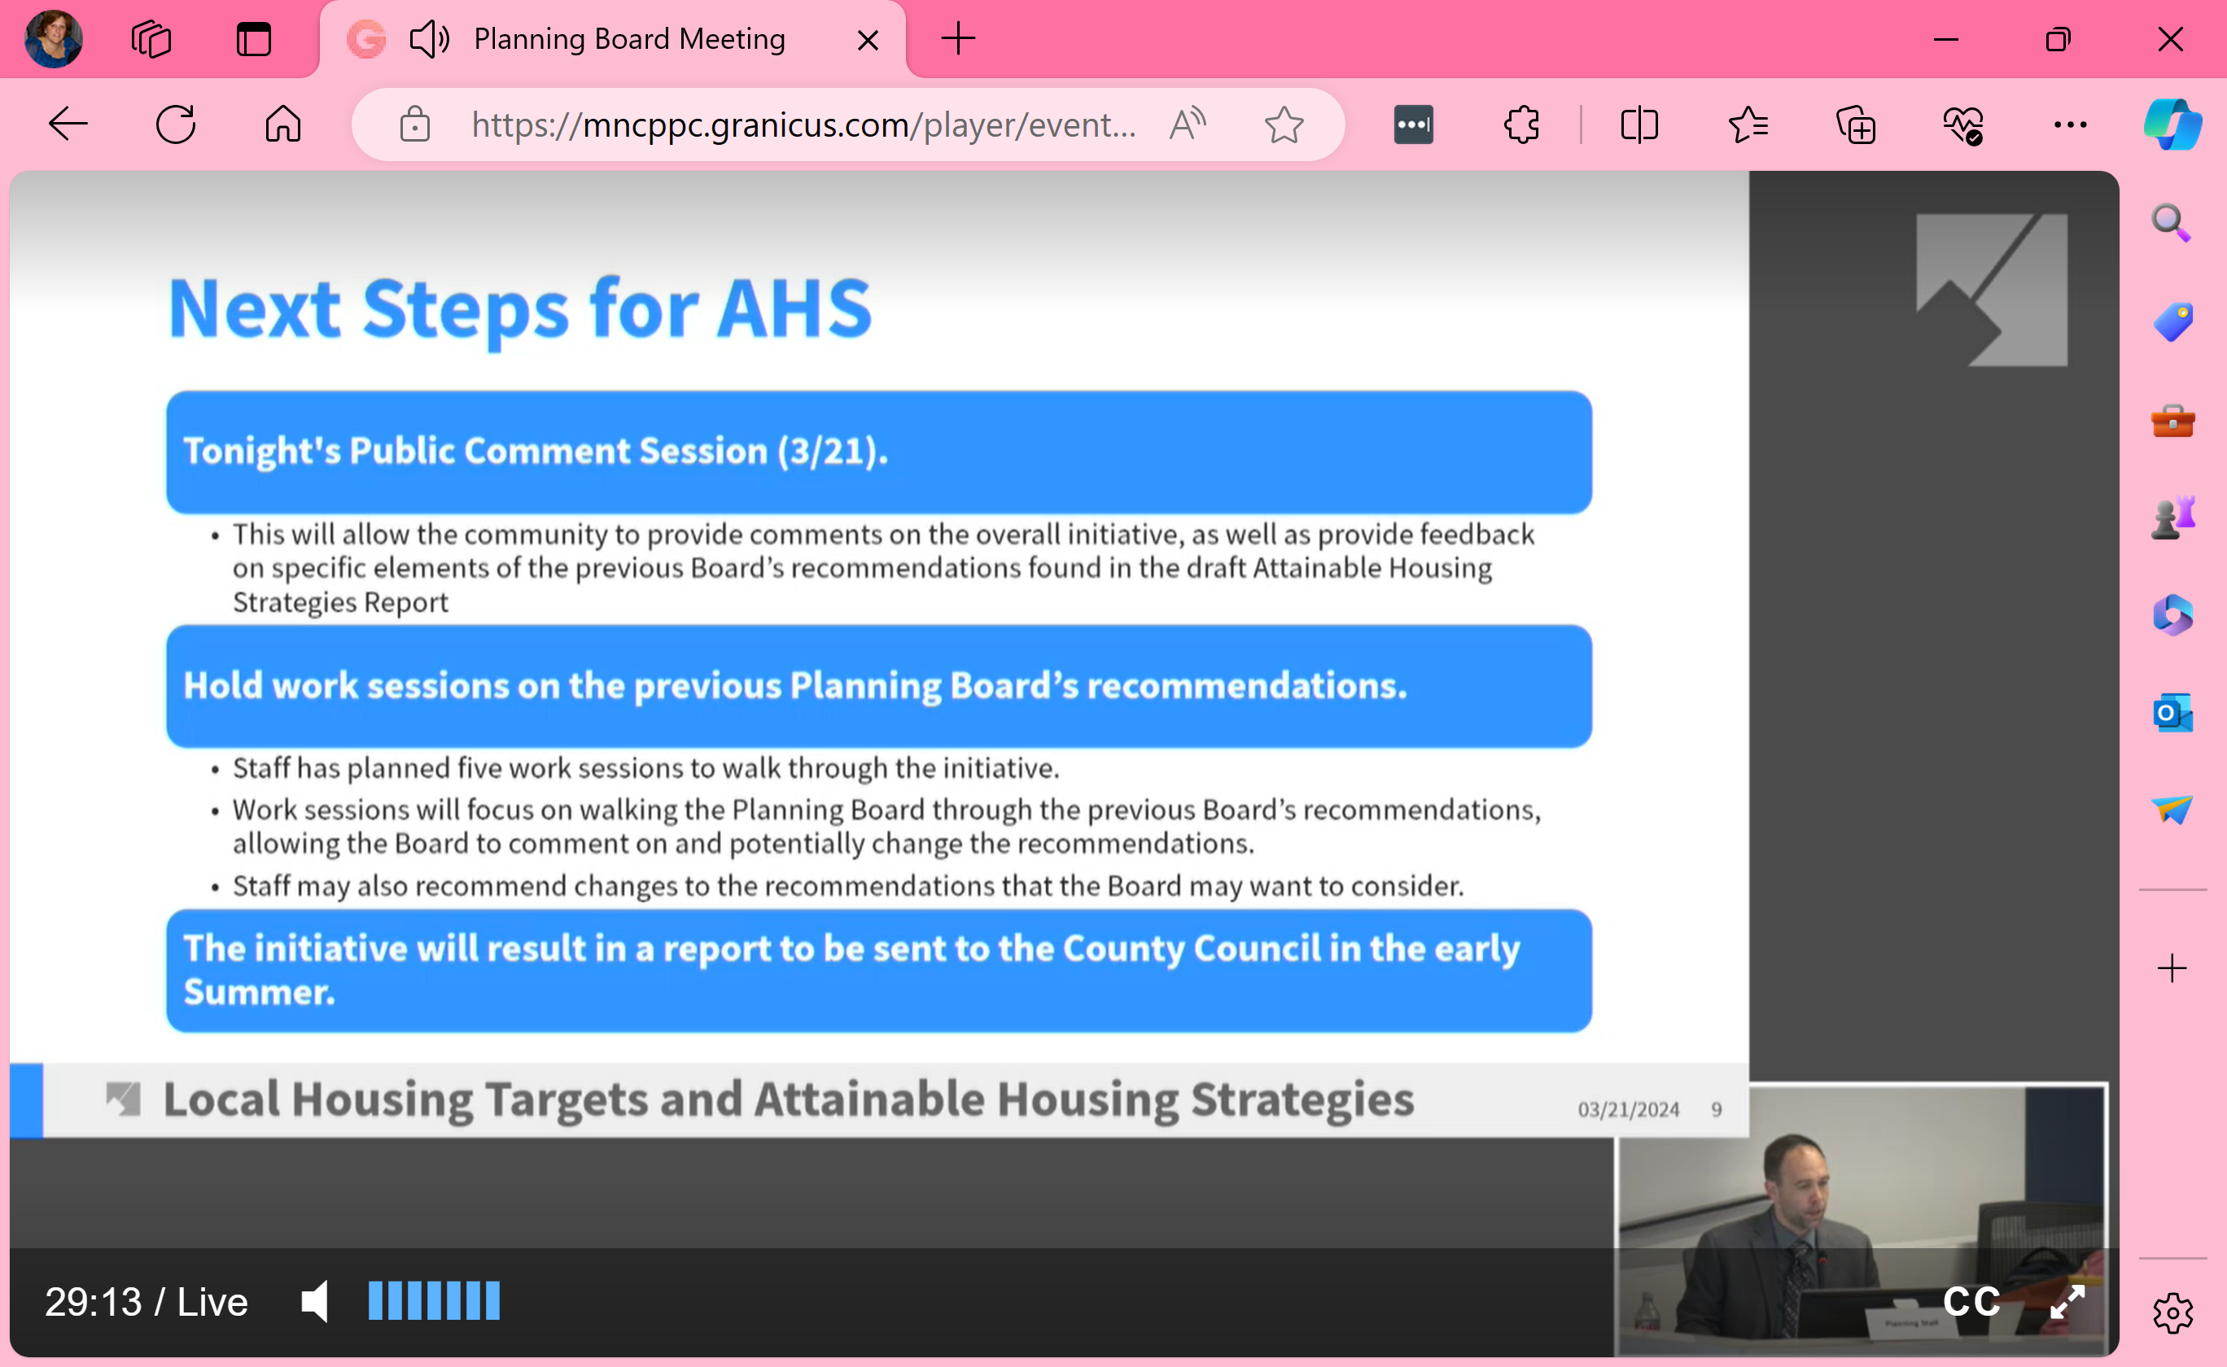
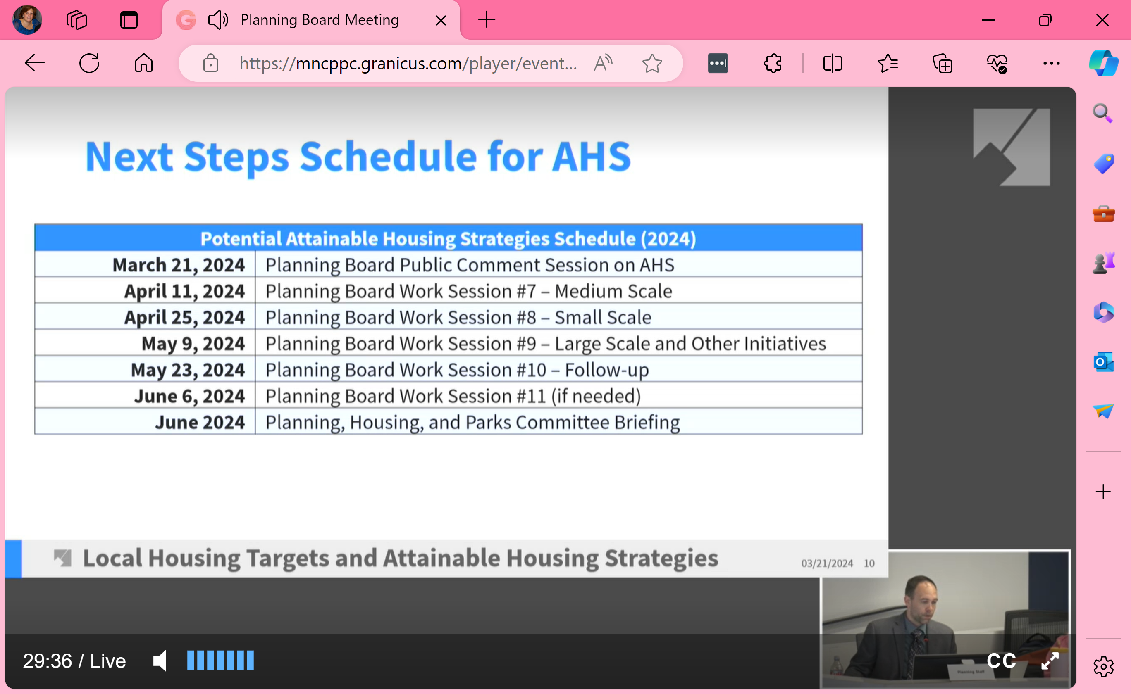

Live Speakers:
1 - Adam P. – homeowner in MoCo, in support
2 – Jordan D. – young renter in Silver Spring, in support; grew up Bethesda and concerned he can’t afford to purchase a home in Bethesda where he grew up.
3 – Caroline L. – lives in DT Silver spring, in support, disabled
4 – Michael L. – MoCo Coalition for ?; in support
5 – Mike E. – lives in downtown Silver Spring; in support; talked about general fear of change
6 – Jane L. – lives in Silver Spring; in support, land-use laws prioritize single family homes, 95% of MoCo homes are single family
7 – Jeffrey E. – lives in east Bethesda; endorses efforts to expand affordable housing and helping homeless; plans to rezone areas to accommodate attainable housing need more study to address infrastructure challenges. Talked about role of developers in this effort. Units will be purchased by investors not homeowners; windfall to developers. Mass transit comments; not yet at pre pandemic levels. Many streets cannot accommodate cars, water run off issues. Many speakers this evening are on MoCo For All Steering Committee; need to be transparent.
8 – Grant R. – in support
9 – Jake G. – on Action Committee for Transit, suggested reducing parking minimums; need land for units not cars
10 – Takoma Park resident – in support. He showed a photo of a duplex in his neighborhood. Note: This duplex was a Habitat for Humanity project in 2023 (I participated in that project). Habitat turned this single-family home into a duplex because the cost of keeping it a single-family home for a Habitat family would have been prohibitive. Habitat turned this 4-bedroom home into two 2-bedroom homes.

Virtual Speakers:
11 – Unknown - Architect living in Kentlands, in support
12 – Matt P. – commercial real estate agent; lives in Friendship Heights (CCFHH); represents 20,000 homeowners (similar to GOCA group); recommended more transportation solutions, current land and construction costs will make new “affordable” housing more expensive than existing homes, noted parking concerns with increased density; planning needs to be more comprehensive.
13 – Dan W. – President of Greater Colesville Civic Assn; not in support; proposed planning makes sense for NEW development but not in existing neighborhoods; adding more units to current lots will impact parking as well as traffic on small roads for 2 cars to pass, impacts emergency vehicles and school buses; adds to storm water mgmt. issues
14 – Carter D. – lives in Takoma Park; member of MoCo For All Steering Committee; housing shortage causes higher prices; in support of more housing in all areas; not content with the pace of change
15 – Michael D. – in support, need to start taking action
16 – Brandy P. – lives in Silver Spring; MoCo For All Steering Committee member; in support
17 – Martin P. - lives in Silver Spring; MoCo For All Steering Committee member; in support, need to focus on transit corridors, county needs flexibility not restrictions
18 – Kevin S. – 2nd gen Asian American renter; in support, also need transit to be more viable
19 – Jonathan R. – lives in Rockville; Chair of Affordable MD PAC; in support; also wants speedy action
20 – Michael D. – lives in Silver Spring; in support, need more housing options that are denser with public transportation access
21 – Ms. Miller – in support, also need to address issues like coaches, mice and gas leaks in existing apartments. Need to fix things for low-income, disabled and homeless
22 – Unknown - talked about housing fixes that worked; in support

- The MoCo Planning Board will continue to accept correspondence throughout the initiative (until end of May).
- Next hearing is April 11th.

